STANDARD SHANK COUPLERS - ENLARGING THE CENTER HOLE

Note: My first and unsuccessful attempt to install Sergents on the Rapido NP boxcar required the enlargement procedure described below. Although the attempt was unsuccessful, this procedure is sound. The following was copied from my initial version of the instructions for the NP boxcar.

The center hole of the Sergents must be enlarged to fit over the boss in the coupler pocket. Begin with a #30 bit and complete with a #29. Do this before assembling the coupler. Initially, I broke two Sergent castings trying to enlarge the hole. Then I created the jig seen in the photos below, labeled "Sergent Jig 1". On a small scrap piece of 1 x 2 pine I used a router bit to create a flat hole large enough for the knuckle end of the Sergent casting to rest in, thus enabling the shank to lie flat on the surface of the wood - with the small hole in the middle of the shank facing up. Then I drilled four pilot holes with a #60 drill bit to hold roundhead brass wood 0 x 3/8 screws. I located the holes so that the shank of each screw would clear the edge of the Sergent casting but close enough so that the bottom of the head would contact the outer edge of the casting to hold it in place when drilling to enlarge the mounting hole. This size screw is small enough for the drill bits to clear the edge of the head when enlarging the hole

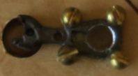 | 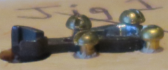

REDUCING THE THICKNESS OF THE SHANK

Note: My first and unsuccessful attempt to install Sergents on the Rapido NP boxcar also required reducing the thickness procedure described below. Although the attempt was unsuccessful, this procedure is sound. The following was copied from my initial version of the instructions for the NP boxcar.

The couplers applied at the factory have very thin shanks that are necessary to clear the opening in the coupler pockets and swing freely. Thin the shanks of the Sergents after assembling them. The Sergent shanks must be reduced considerably, so much so that it's possible the Sergent components might separate from too much filing. Thus it would be good to file only the part of the shank that sits within the coupler pocket. File the Sergents to .040" at the large hole end and about .047" at the knuckle end. I created a jig on scrap 1 x 2 x 7 pine to do the filing. I routed a hole large enough to rest the knuckle on while allowing the shank to rest flat on the wood. I added a small nail to hold the hole end of the casting in place while filing. I use a fairly large file to minimize the time it takes to do the filing. I filed down both sides of the shank equally while using my left index finger to hold the piece steady while filing.

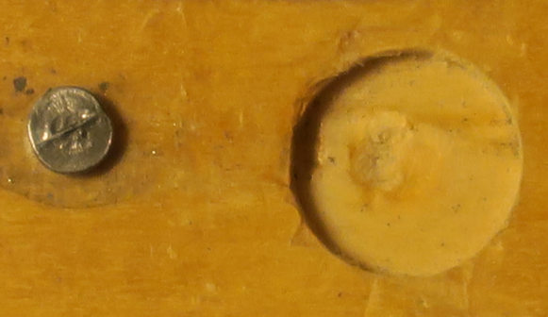 | 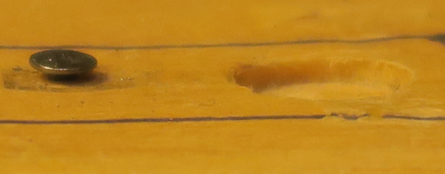 | 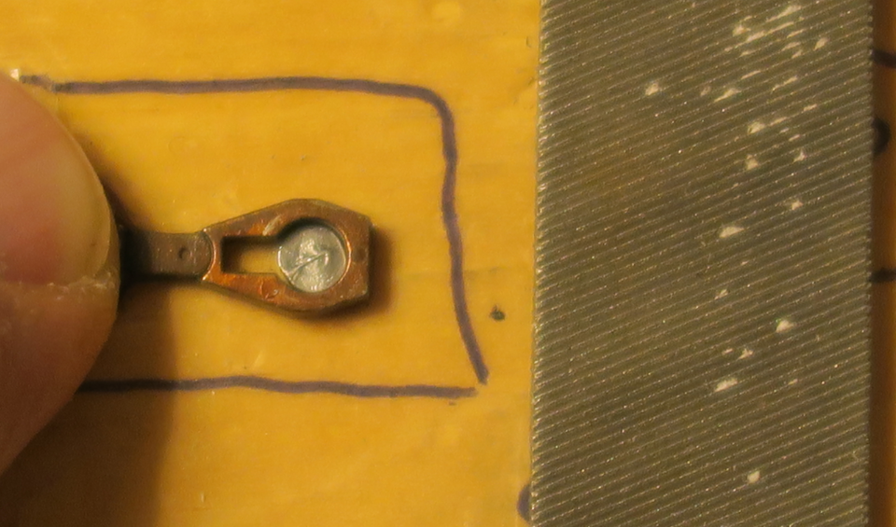

I use a Dremel #280 drill with an infinite speed control and a drill press. The drill cannot accept a drill bit greater in size than a #30. I had a machinist reduce (to #31) the end of the shank on 15 selected oversize bits from #29 to #1 so I could use them in my Dremel. I made a stand for my drill bits from a piece of 1 x 3 pine. Bit sizes include 1, 5, 10, 14, 17, and 20 to 60.

